**Steps to run the Covid19 Predictor**

**Prerequisites**

You must have Scikit Learn, Pandas (for Machine Learning Model) and Flask (for API) installed.

**Model Structure**

This deployed model has three major parts :

1. model.py - This contains code for our Machine Learning model to predict Covid19 on training data in 'Cleaned-data.csv' file.
2. app.py - This contains Flask APIs that receives user input through GUI and computes the predicted value based on our model and returns it.
3. templates - This folder contains the HTML template to allow user to enter their details and symptoms and displays the predicted output.
4. ml.pkl – This contains the pickle file of the predictor.

### Running the Deployed Model

1. Run app.py using below command to start Flask API. Ensure that you are in the local directory of the model containing app.py and ml.pkl file.

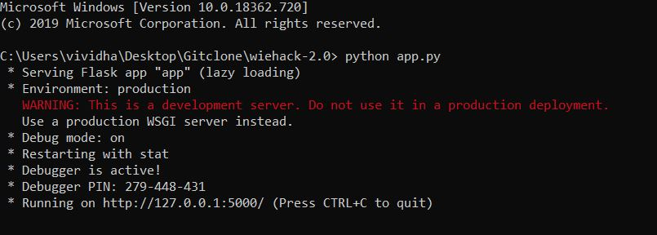

By default, flask will run on port 5000.

1. Navigate to URL http://127.0.0.1:5000/

The homepage will look like this :

